Captain Robert Justice Fairclough
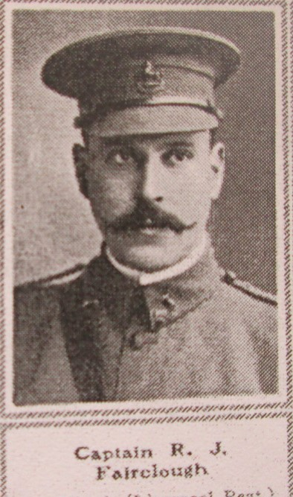
Family Background
Robert was born at Aughton near Ormskirk, Lancashire in 1874, the only son of James Stanley and Fanny McBride Fairclough, who later lived at “Elderslie”, Coed Coch road, Old Colwyn.
Robert was educated at Denstone College, Uttoxeter, and later, by the age of sixteen had followed in his father’s footsteps working in the Cotton Exchange at Liverpool as a broker.
Military Service
From his obituary in the Sphere newspaper, it is known that Robert had previously served with the Grenadier Guards; however by April 1908 he was serving as a Captain in the 1st Volunteer Battalion King’s Liverpool Regiment, the forerunner to the Territorial Force.
Although his medal index card states that he was attached to the King’s Liverpool Regiment from the Royal Welsh Fusiliers, it is known that he embarked for France with the 1/5th Battalion, Territorial Force the King’s Liverpool regiment on the 21st February 1915, attached to the 6th Brigade, 2nd Division. We can find no details of any service with the R.W.F
Casualty Details
After a brief period of trench training, the battalion commenced holding front line trenches, taking part in the holding attack at Givenchy on the 10th March (Battle of Neuve Chapelle) and in reserve during the Battle of Aubers Ridge (9th May 1915).
The Battle of Festubert opened at 11.30pm on the 15th May with the battalion once again in brigade reserve. Two Companies were attached to the Royal Engineers to construct a communication trench, but little was achieved as the attack was unsuccessful. In an effort to renew the attack the remaining Companies moved up to the front line at 4.00am on the morning of the 16th May, 1915. Colonel McMaster was ordered to make a careful reconnaissance but after speaking with officers from other battalions he reported that a further attack would be impracticable and would lead to heavy casualties. The Brigadier however ordered the attack.
The attack commenced at 8.00am but was held up by enemy rifle and machine gun fire. Throughout the day the many wounded struggled to crawl back across No Man’s Land; ably assisted by Major Cohen, Captain Fairclough, Sergeant Cooney and Riflemen Benbow and Hoy. It was during this period whilst bringing in Lieutenant George Herbert Cohen – brother of major Stanley Cohen – that Captain Fairclough received gun-shot wounds. He was evacuated to the base hospital at Boulogne but died some days later of his wounds.
Additional Information
Robert’s father, James Stanley Fairclough moved to Old Colwyn sometime after the death of his wife (1903). His house name, “Elderslie”, is a corruption of Elders Lane; the family home where his son Robert was born. His father, who had gone to France to see his wounded son, was in attendance at his funeral.
Robert’s medals were requested by his sister, Amy, who worked as a private nurse for the reverend Cormack, at Kingsdon Rectory, Taunton, Somerset. Robert never married.
In addition to his commemoration on the Old Colwyn War Memorial, Captain Robert Justice Fairclough is remembered on the war memorial at Denstone College and the Old Cotton Exchange Memorial in Liverpool.
Major Stanley Cohen survived his wounds and the war. Riflemen Benbow and Hoy were recommended for the Distinguished Conduct Medal for their bravery, as was Sergeant Cooney. Hoy and Cooney survived the war; however George Parkin Benbow died on the 8th August, 1916. He was awarded the M.M for his bravery and later promoted sergeant. He has no known grave and is commemorated on the Thiepval Memorial, Somme.
In spite of Robert’s efforts to save Lieutenant George Herbert Cohen, he subsequently died of his wounds and is buried at Guard’s Cemetery, Windy Corner, Cuinchy.

Grave of Captain Fairclough, Boulogne Eastern Cemetery, Pas de Calais, France. Inscription translates: God, County, King
