2120 Private John Herbert Bellis

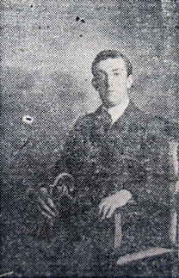
Family background
John was born to parents John & Hannah Bellis at Much Wenlock, Shropshire in 1894. His father was a gardener and by 1901 (census) the family had moved to 3 Rose Hill, Old Colwyn; John (Herbert) was 7 years old and had a younger sibling, Ann Elizabeth aged 5.
By 1911 (census) the family had moved to Gorddinog, Abergele road (now The Rock, junk shop), Old Colwyn. John (Herbert), now 17 years of age was employed as a house painter. His younger sister was a dressmaker.

Military Service
Little is known about how John Bellis (middle name not used on his military records) enlisted in to the 5/Royal Welsh Fusiliers, however, his service number – 2120 – indicates that he most likely enlisted after the outbreak of war, joining his battalion during their period of training in the U.K, before embarking for Gallipoli in July 1915 and the ill fated landings at Sulva Bay, Gallipoli, the following month.

Casualty Details
After initially being reported as missing, it was later “assumed” that Private John Herbert Bellis was one of 29 other ranks who were killed in action during the attack. His body was never found and he is commemorated on the Helles memorial to the missing, Gallipoli.

Additional Information
In 1913 after the death of his mother, John Herbert’s father immigrated to Canada. In February 1917 he enlisted in to the Canadian Expeditionary Force, 256th battalion (service number 1099717). His daughter followed her father to Canada in 1918, where she later settled and married. It is unknown if there are relatives still residing in the area.

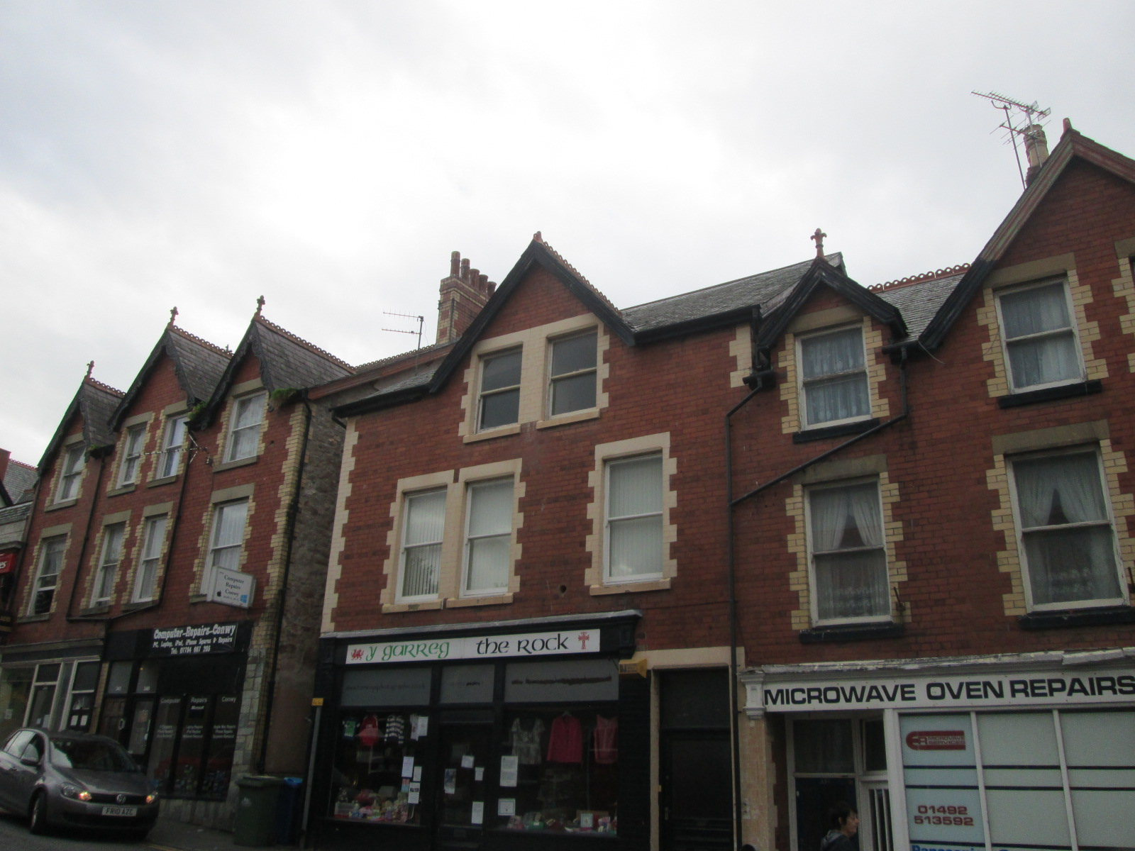

Gorddinog, Abergele Road

