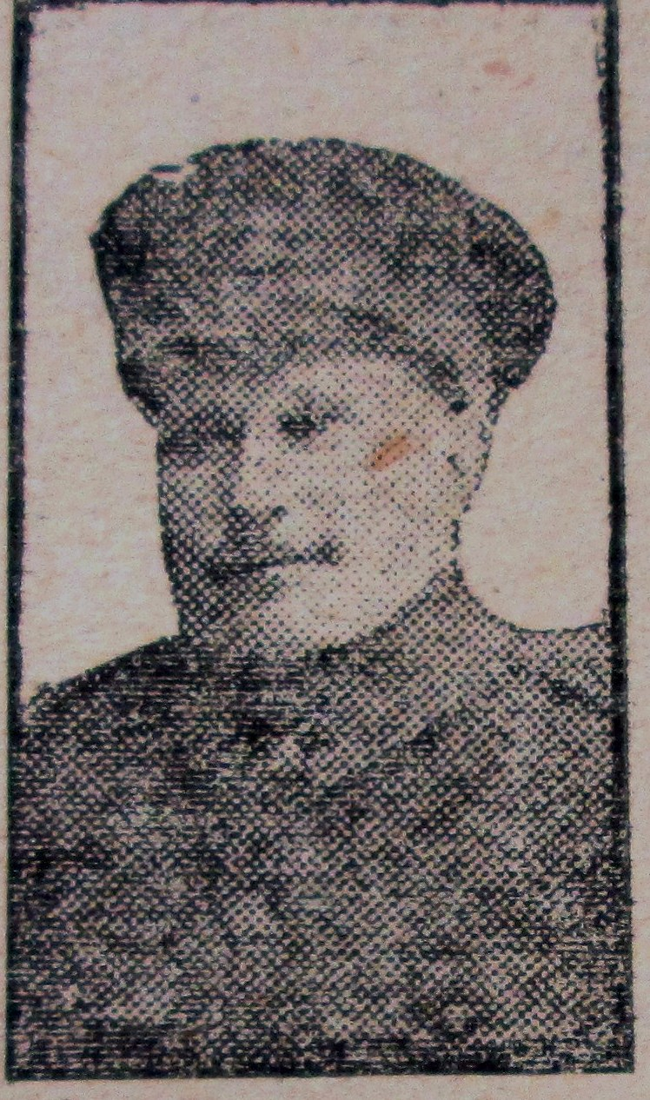
John Davies

Family background
John Davies was born in Abergele in1875, his father Robert, was the parish clerk. He married Maria in 1898 and they went on to have four children. In 1901 the couple lived at 7, New Street, Abergele with John working at the local tannery. By 1911 the couple lived at 34 Peel Street, Abergele, with John now employed as a general labourer.
By 1914, the family had moved to Mona Villa, Wellington Road, Old Colwyn where John was “well known as a local craftsman” (Pioneer Newspaper).

Military Service
Little is known regarding Private John Davies’s enlistment in to the 5th Battalion Royal Welsh Fusiliers. His service number – 2648 – suggests that he enlisted after the outbreak of war, but went with the battalion to Gallipoli in July 1915 and the ill fated Sulva Bay landings a month later.

Casualty Details
His death was reported in the local newspaper which stated that he was killed by a sniper whilst “carrying rations to his mates in the trenches”. Although it went on to report that he was “buried with honours at Anafarta Sagir, on the Gallipoli Peninsula”, his grave was later lost. Today he is commemorated on the Helles Memorial, Gallipoli.

Further Information
His last letter home included these words: “Pray for me, and god be with you till we meet again”. His wife, Maria later remarried and moved to Bristol with their four children. At 40 years old Private Davies is one of the oldest men commemorated on the memorial. John is also commemorated on the Abergele war memorial.

