John David Jones

Family Background

John was born in Old Colwyn in May 1889; the 1891 census shows the family living at 4 Rhos View Terrace, Lysfaen Road. He later had connections with Liverpool House, Abergele Road - but by the 1901 census he was living in Festiniog with his mother and his four brothers; the eldest of which is shown as head of the household working as a quarryman and the main bread winner of the family.
The family moved to Liverpool and by 1911 were living under the same roof at 4 Roby Street, Wavertree. John, like his brothers – at this time - was an unemployed labourer.

Military Service

On 31st July 1911, John enlisted in to the 3rd (Special Reserve) Battalion Royal Welsh Fusiliers, at Litherland, Liverpool. His six year commitment - after initial training - was to attend yearly training and serve overseas during times of war. Meanwhile he remained at home, continued to work (by now he was working as a cotton porter) and paid a retainer to remain in the army reserve.
On the out break of war John was mobilized from the reserve, reporting to the regimental depot at Wrexham where he was posted to the 1st Battalion R.W.F on the 19th September 1914.

Casualty Details

His battalion disembarked at Zeebrugge, Belgium on the 7th October 1914 as part of the 7th Infantry Division. After failing to help prevent the fall of Antwerp, the 7th Division arrived in Ypres on the 14th October 1914 where a general advance began against the German forces; it became known as the First Battle of Ypres.
Private John David Jones was killed in action 19th – 20th October 1914, after the 1st Battalion R.W.F came under heavy attack as it advanced on the town of Menin.
1st Battalion R.W.F suffered 231 casualties: killed or died of wounds during the First Battle of Ypres. Like Private Jones, the vast majority have no known grave and are commemorated on the Memorial to the Missing on the Menin Gate, Ypres.

Additional Information

John married Mary (Crooks) on the 31st March 1914 and resided at 9 Godwin Street, Toxteth Park, Liverpool. On the 14th January 1915 Mary gave birth to a baby girl – Mary Kathleen. She registered the child’s father as her deceased husband, John David Jones; tragically, aged three months, the child contracted bronchial pneumonia, which proved fatal.
There is a memorial to John in Hebron Church, Old Colwyn.

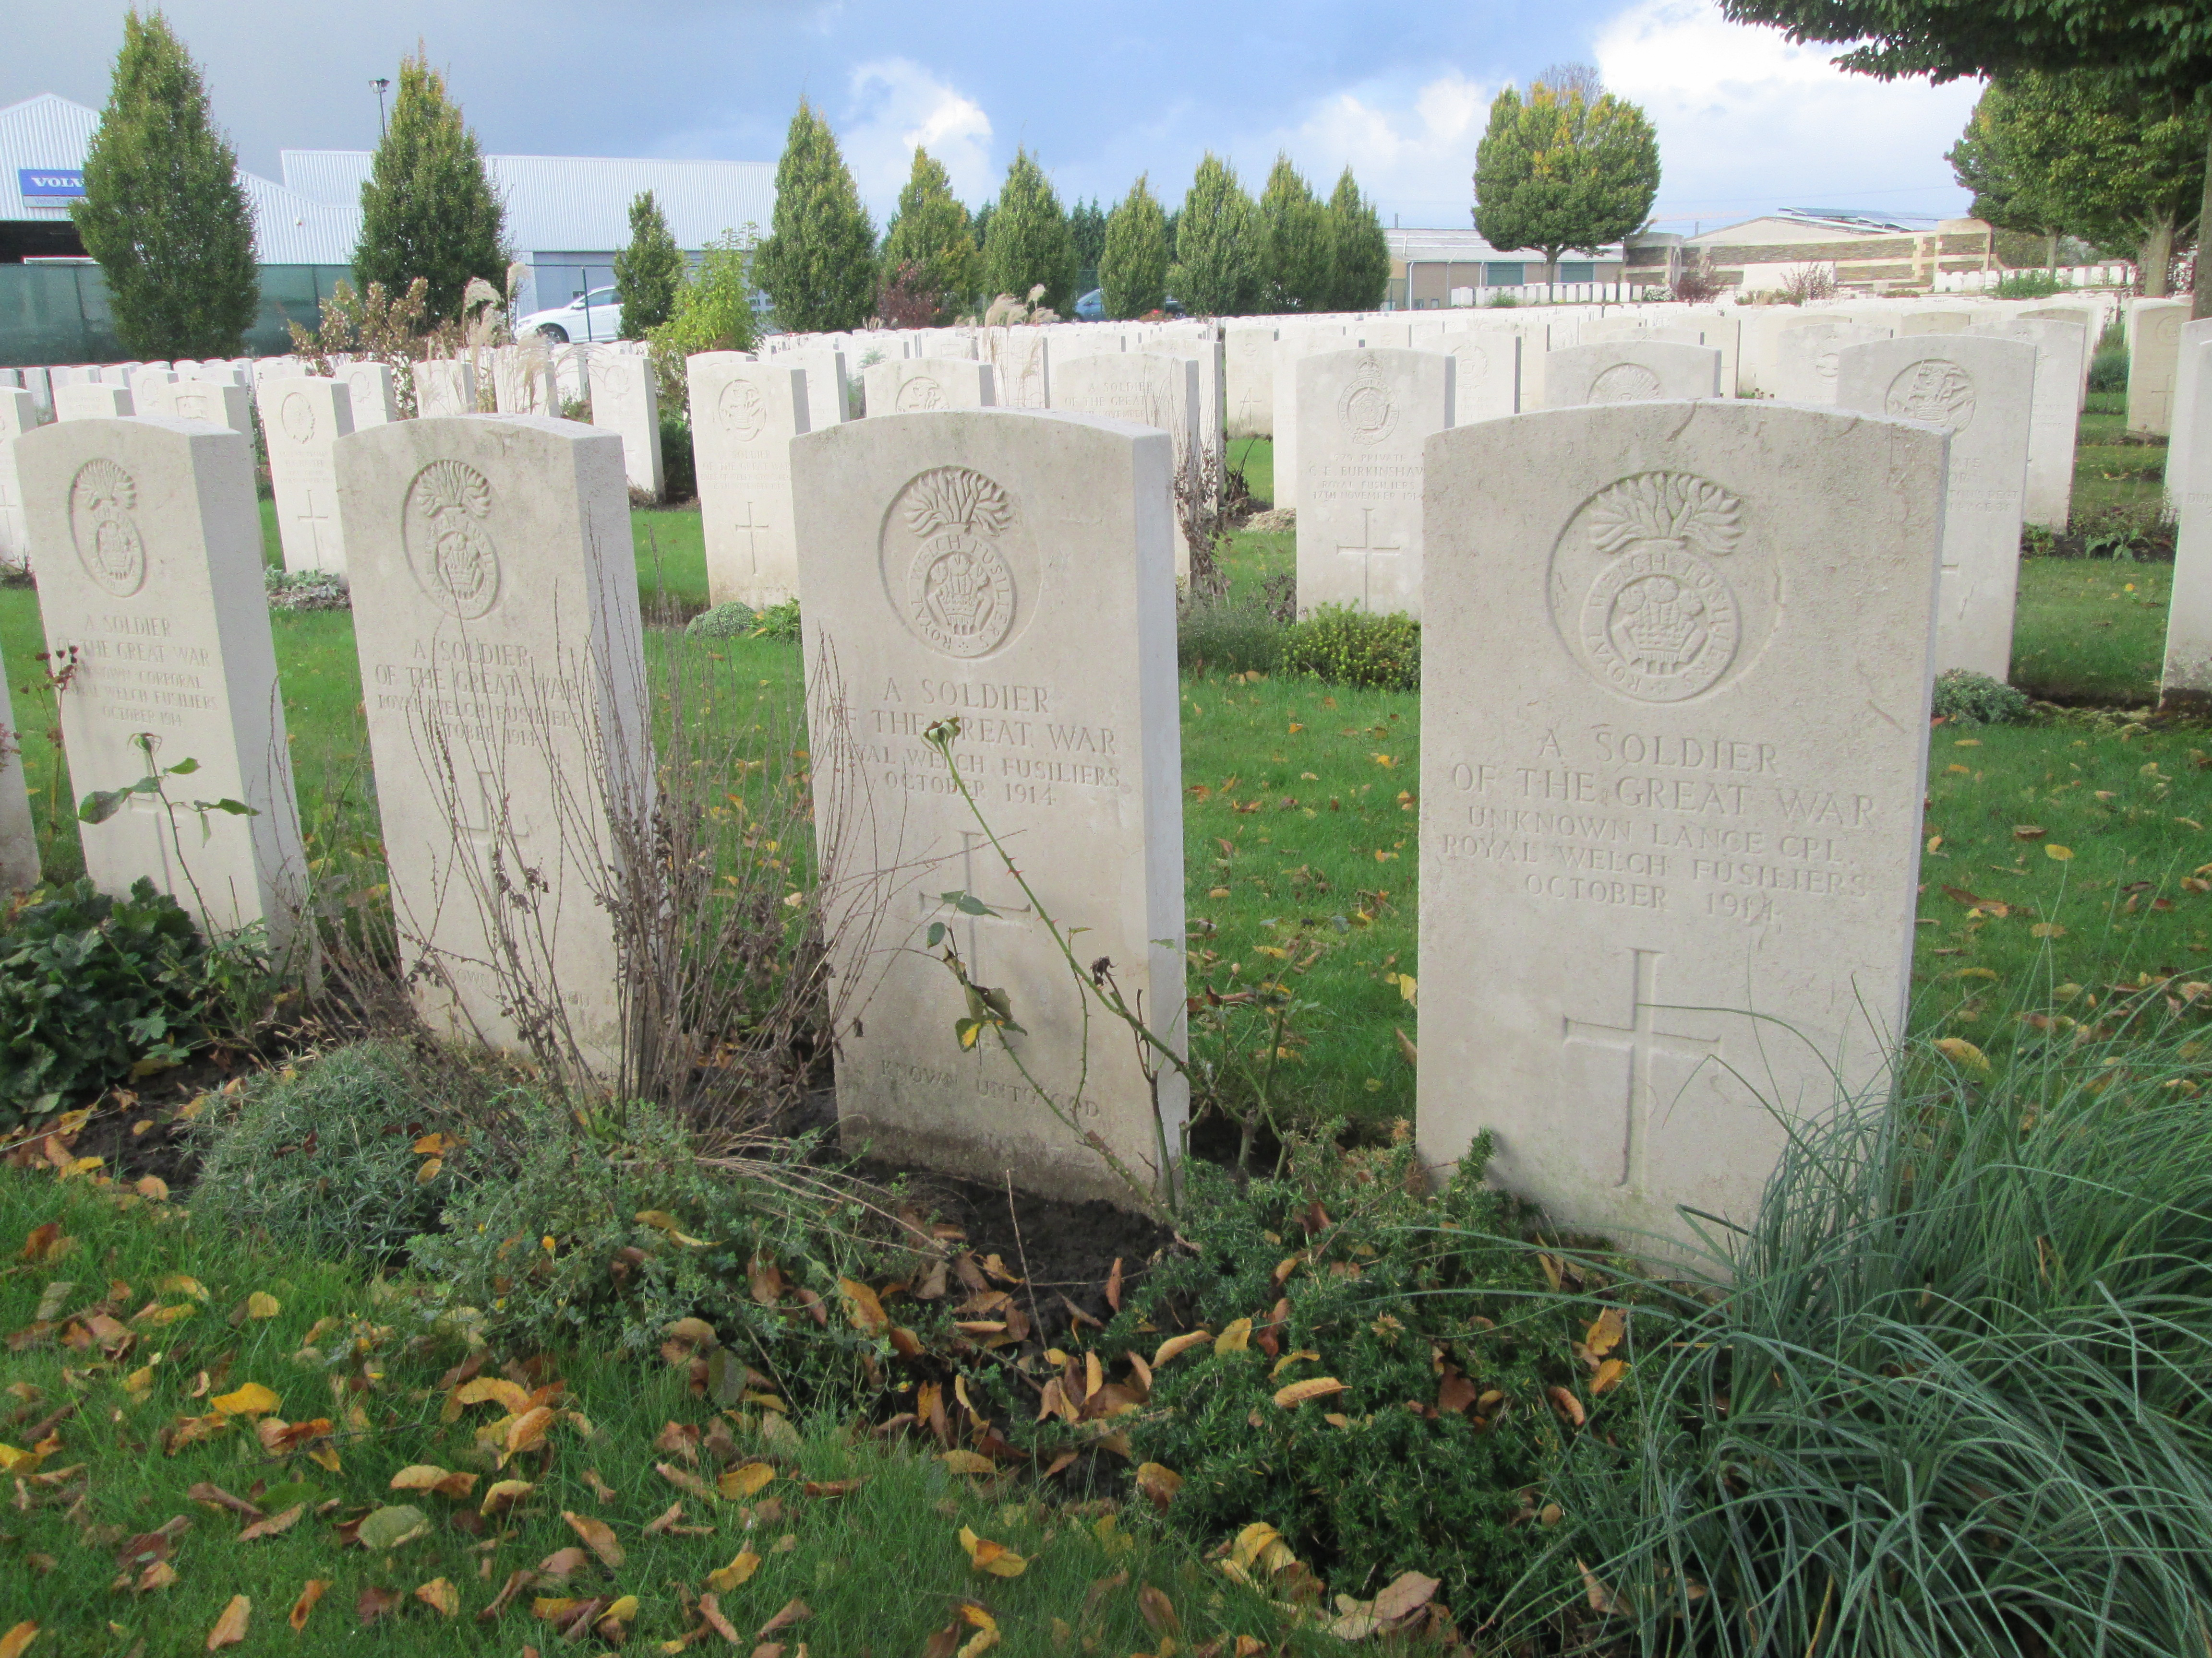

Unknown Royal Welsh Fusiliers buried in Harlebeke Cemetery, Belgium.

During the post war years the majority of German burial grounds in Belgium containing British war dead were exhumed, identified (where possible) and reburied in to purpose built British cemeteries. The Royal Welsh graves (pictured above) were exhumed from Gheluwe Churchyard, where it is believed those of the 1st Battalion were original buried (by the enemy). Could one of these be the grave of John David Jones?

